Rolling correlation: GBPUSD and USDCHF
Method 05 / daily log returns / windows 20, 60, 100 / Secondary tier

Study setup
Logical pair: GBPUSD , USDCHF
Broker symbols: GBPUSD_i , USDCHF_i
Tier: Secondary tier (secondary)
Snapshot: 2026-11-03_majors_alpari_D1
Timeframe: D1
Matched return window: 1999-01-05 to 2026-11-02 (UTC bar dates)
Matched return count (rows before rolling): 7201
Dropped unfinished last bar dated 2026-11-03 UTC after a tick-volume check against the prior complete day.
Rolling windows W: 20, 60, 100 trading days
Live-shaped n for each score: n = W (not the full history length)
Complete matched rows (CSV): GBPUSD-USDCHF_Rolling_D1.csv
Complete matched rows (HTML): GBPUSD-USDCHF_Rolling_D1_data.html

Method carried forward
Rolling Pearson r is computed on matched daily log returns of close, ln(close_t / close_t-1), in the broker quote direction. Quotes are not inverted. For each day t with a full window, r_W uses the last W matched return pairs ending at t. That live-shaped sample size is W (20, 60, or 100), not the full multi-year history. The first W-1 days have no score. r is symmetric under swap of the two symbols. A high |r| in one window does not prove cause, lead-lag, or a trading signal. Short windows are noisier; long windows are slower to reflect a break.
How to read a live day: after both daily candles close, the newest r_20 uses the last 20 matched log returns, r_60 the last 60, and r_100 the last 100. Compare those three to each other and to the full-sample baseline below. A break is when the short window moves far from the baseline or flips sign while the baseline was meaningful.

Full-sample Pearson baseline (method 01 v001)
Copied full-sample Pearson r for GBPUSD-USDCHF: -0.486083. This is a historical average link, not the live state.

Rolling results
W | latest_r | mean | median | min | max | std | pct_|r|>=0.4 | pct_|r|>=0.7 | n_roll
20 | -0.72844 | -0.563896 | -0.615482 | -0.959471 | 0.545928 | 0.23192 | 78.42 | 32.26 | 7182
60 | -0.637713 | -0.560193 | -0.582897 | -0.926759 | 0.094379 | 0.183664 | 81.46 | 24.25 | 7142
100 | -0.702638 | -0.557079 | -0.569104 | -0.910633 | -0.044617 | 0.171379 | 80.99 | 23.64 | 7102
n_roll is the number of days that had a complete window. pct_|r|>=0.4 and pct_|r|>=0.7 are the share of those days where the absolute rolling correlation cleared the threshold.

Conclusion
For GBPUSD and USDCHF, full-sample Pearson baseline r=-0.4861. Latest rolling scores: r_20=-0.7284, r_60=-0.6377, r_100=-0.7026. Stability: moderate window-to-window variation. Agreement with baseline: r_20=-0.728 near baseline; r_60=-0.638 near baseline; r_100=-0.703 near baseline. Tier line: secondary — keep on a lower-priority board next to the watchlist. This is a monitoring summary, not a trade signal.

What to look at in this file next time
1) Latest r_20 vs r_60 vs r_100 in the results table. 2) Whether short-window latest has the same sign as the baseline. 3) The rolling chart for stretches where |r| collapsed. 4) The CSV if you need a different chart later.

Charts
Rolling Pearson r (20 / 60 / 100)
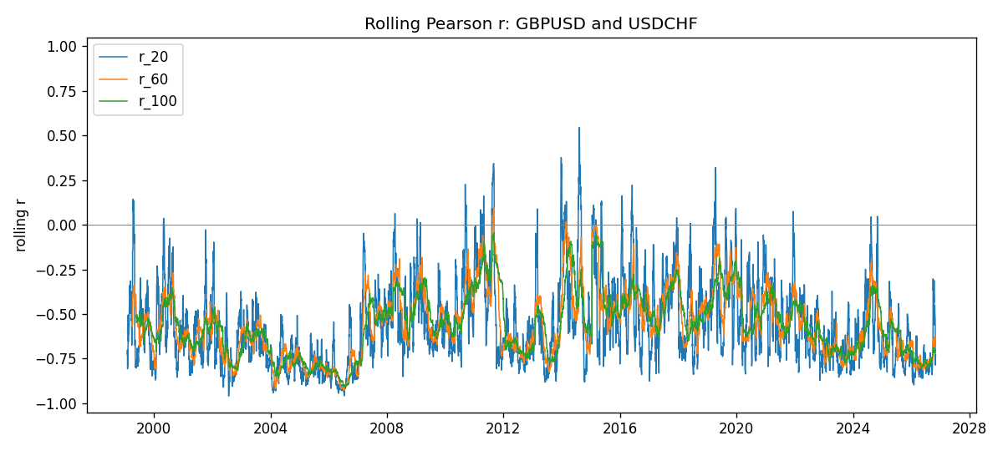
Daily closes

Daily log returns
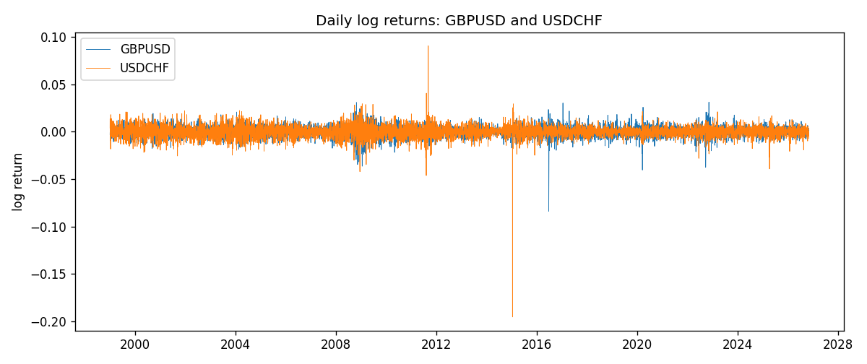

Data report
Every matched row with r_20, r_60, and r_100 is in the sibling CSV and HTML. This Word section holds column summaries and the first and last 15 rows of the rolling table.
Columns: time, GBPUSD_close, USDCHF_close, GBPUSD_tick_volume, USDCHF_tick_volume, GBPUSD_log_return, USDCHF_log_return, r_20, r_60, r_100
Column summaries
column | count | mean | std | min | 25% | 50% | 75% | max
GBPUSD_close | 7201 | 1.51615 | 0.21823 | 1.06879 | 1.3251 | 1.5114 | 1.63212 | 2.1065
USDCHF_close | 7201 | 1.09829 | 0.252542 | 0.72025 | 0.92098 | 0.9902 | 1.2387 | 1.8217
GBPUSD_tick_volume | 7201 | 94828.1 | 153546 | 62 | 10002 | 52900 | 91806 | 1.27337e+06
USDCHF_tick_volume | 7201 | 74189.3 | 113410 | 18 | 12770 | 40195 | 70240 | 858589
GBPUSD_log_return | 7201 | -2.316e-05 | 0.00564524 | -0.0838824 | -0.00312969 | 3.242e-05 | 0.00318104 | 0.0311265
USDCHF_log_return | 7201 | -7.148e-05 | 0.00659332 | -0.195457 | -0.00335964 | 8.06e-05 | 0.00331782 | 0.0905136
r_20 | 7182 | -0.563896 | 0.23192 | -0.959471 | -0.734241 | -0.615482 | -0.436543 | 0.545928
r_60 | 7142 | -0.560193 | 0.183664 | -0.926759 | -0.696217 | -0.582897 | -0.445012 | 0.0943794
r_100 | 7102 | -0.557079 | 0.171379 | -0.910633 | -0.692571 | -0.569104 | -0.446329 | -0.044617
First 15 matched rows
time | GBPUSD_close | USDCHF_close | GBPUSD_log_return | USDCHF_log_return | r_20 | r_60 | r_100
1999-01-05 | 1.6547 | 1.3724 | -0.00289663 | 0.00394247
1999-01-06 | 1.6537 | 1.3912 | -0.000604522 | 0.0136057
1999-01-07 | 1.6502 | 1.3782 | -0.00211871 | -0.00938838
1999-01-08 | 1.6405 | 1.3935 | -0.00589542 | 0.0110403
1999-01-11 | 1.6312 | 1.4009 | -0.00568513 | 0.00529632
1999-01-12 | 1.6349 | 1.3872 | 0.0022657 | -0.00982756
1999-01-13 | 1.6499 | 1.3621 | 0.00913304 | -0.0182597
1999-01-14 | 1.6531 | 1.3588 | 0.00193763 | -0.00242567
1999-01-15 | 1.6502 | 1.3834 | -0.00175582 | 0.0179423
1999-01-18 | 1.6522 | 1.379 | 0.00121124 | -0.00318564
1999-01-19 | 1.6553 | 1.3789 | 0.00187453 | -7.25189e-05
1999-01-20 | 1.6472 | 1.3889 | -0.00490538 | 0.00722599
1999-01-21 | 1.6524 | 1.3836 | 0.0031519 | -0.00382327
1999-01-22 | 1.6565 | 1.3834 | 0.00247817 | -0.000144561
1999-01-25 | 1.6585 | 1.3868 | 0.00120664 | 0.0024547
Last 15 matched rows
time | GBPUSD_close | USDCHF_close | GBPUSD_log_return | USDCHF_log_return | r_20 | r_60 | r_100
2026-10-13 | 1.32534 | 0.83244 | 0.00364343 | -0.00249556 | -0.434557 | -0.647903 | -0.690159
2026-10-14 | 1.31884 | 0.83489 | -0.00491647 | 0.00293883 | -0.311911 | -0.64906 | -0.689569
2026-10-15 | 1.32757 | 0.82676 | 0.00659764 | -0.00978553 | -0.505838 | -0.675332 | -0.704199
2026-10-16 | 1.33257 | 0.82377 | 0.00375921 | -0.00362308 | -0.515152 | -0.681085 | -0.708336
2026-10-19 | 1.33024 | 0.82677 | -0.00175003 | 0.00363518 | -0.533181 | -0.68391 | -0.717995
2026-10-20 | 1.3377 | 0.8246 | 0.00559234 | -0.00262812 | -0.562435 | -0.682096 | -0.718497
2026-10-21 | 1.33937 | 0.82427 | 0.00124763 | -0.000400274 | -0.49306 | -0.666841 | -0.714971
2026-10-22 | 1.33967 | 0.82032 | 0.000223961 | -0.00480364 | -0.451491 | -0.62359 | -0.712238
2026-10-23 | 1.33684 | 0.82497 | -0.00211469 | 0.00565251 | -0.487919 | -0.636438 | -0.702593
2026-10-26 | 1.33359 | 0.82649 | -0.00243407 | 0.0018408 | -0.518873 | -0.632138 | -0.703538
2026-10-27 | 1.33044 | 0.82865 | -0.00236484 | 0.00261005 | -0.525035 | -0.632546 | -0.707835
2026-10-28 | 1.33254 | 0.82781 | 0.00157718 | -0.00101421 | -0.56286 | -0.631702 | -0.708023
2026-10-29 | 1.33733 | 0.82379 | 0.00358819 | -0.00486802 | -0.786063 | -0.643501 | -0.708081
2026-10-30 | 1.33913 | 0.82438 | 0.00134506 | 0.000715946 | -0.776577 | -0.633907 | -0.707168
2026-11-02 | 1.3406 | 0.81851 | 0.00109713 | -0.00714597 | -0.72844 | -0.637713 | -0.702638

